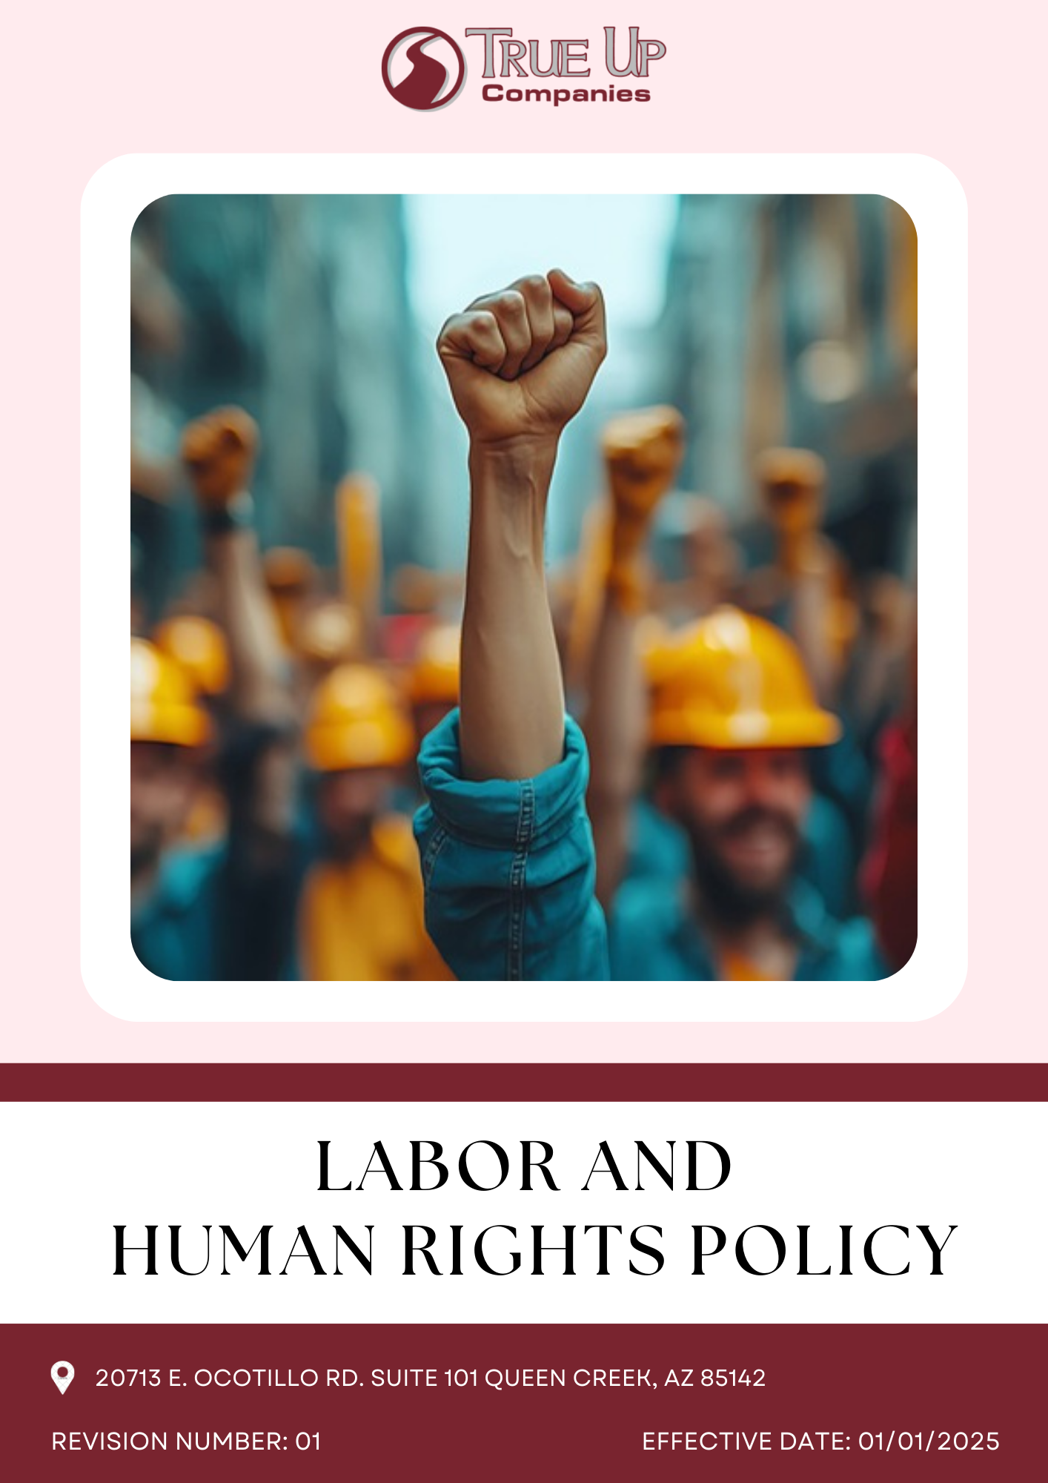

Table of Contents
Introduction 3
Scope 3
Policy Statement 3
Core Sustainability Focus Areas 3
Objective 4
Targets 5
Responsibilities 7
Targets in alignment with SDGs 7
Review Mechanism 7
Employee Acknowledgement 8

Introduction
At True-Up Companies, we recognize that our success is built on the dedication and well-being of the people who power our business from our employees to the workers within our supply chain. We are committed to upholding the highest standards of Labor rights and human dignity in every aspect of our online retail operations. Our Labor and Human Rights Policy ensures fair wages, safe working conditions, and respect for fundamental human rights across our workforce and supplier network. We stand firmly against forced Labor, child Labor, discrimination, and any form of exploitation. By embedding these values into our operations, we aim to foster a responsible and sustainable business model that not only delivers quality products but also promotes social justice and human dignity at every level of our supply chain.

Scope
This policy applies to all employees, contract workers, suppliers, and business partners, ensuring fair wages, safe working conditions, non-discrimination, and the prohibition of forced and child labor across True Up Companies’ operations and supply chain.
TRUE UP COMPANIES LLC
20713 E. Ocotillo Rd. Suite 101 Queen Creek, AZ 85142

Policy Statement
True Up Companies is committed to upholding labor and human rights across all operations and supply chains. We ensure fair wages, safe working conditions, and a workplace free from discrimination, harassment, forced labor, and child labor. By aligning with international labor standards, we foster an ethical, inclusive, and respectful work environment for all employees, partners, and stakeholders.

Core Sustainability Focus Areas
- Safe and Healthy Working Conditions – Maintain workplace safety, health standards, and well-being programs.
- Prevention of Child and Forced Labor – Enforce a zero-tolerance policy on child Labor, forced Labor, and human trafficking.
- Diversity, Equity, and Inclusion (DEI) – Promote a diverse, inclusive, and non-discriminatory workplace.
- Employee Health & Safety – Maintain a proactive safety culture by implementing regular risk assessments and workplace health programs.
- Social Dialogue & Employee Engagement – Foster open communication and grievance mechanisms to ensure transparency and fair treatment.
- Career Growth & Skills Development – Invest in continuous learning and training programs to support employee career advancement.
- Human Rights & Stakeholder Responsibility – Ensure ethical labor practices across operations and supply chains through regular assessments and compliance monitoring.
- Working Hours and Overtime- Adhere to industry standards and legal requirements regarding working hours and overtime to prevent employee exhaustion.
- Mental Health- Implement initiatives to support mental well-being, offering counseling services and stress-management programs.
Objective
- Employees Health and Safety
- Ensure a safe and healthy workplace across warehouses and offices.
- Implement industry-leading safety protocols, regular risk assessments, and emergency preparedness training.
- Provide necessary protective equipment, ergonomic workspaces, and wellness programs for all employees.

- Safe and Healthy Working Conditions
- Maintain fair wages, reasonable working hours, and adequate rest periods in compliance with Labor laws.
- Prohibit exploitative practices, including excessive overtime or unsafe working conditions.
- Ensure warehouse, delivery, and remote work environments meet high Labor standards.

- Social Dialogue & Employee Engagement
- Promote open communication between employees, management, and stakeholders to address workplace concerns.
- Support workers’ rights to collective bargaining and union participation without fear of retaliation.
- Implement grievance mechanisms that allow employees to report concerns confidentially and without reprisal.

- Career Growth & Skills Development
- Provide training and career development programs to support employee growth and skills enhancement.
- Encourage leadership development, mentorship, and internal mobility opportunities.
- Ensure fair promotion and career advancement based on merit and performance.

- Prevention of Child and Forced Labor
- Enforce a strict zero-tolerance policy on child Labor, forced Labor, and human trafficking within True-Up Companies and our supply chain.
- Conduct regular audits and due diligence to ensure suppliers and third-party vendors comply with international Labor standards.

- Diversity, Equity, and Inclusion (DEI)
- Foster a workplace culture that values diversity, equity, and inclusion across all levels of the organization.
- Ensure hiring, promotions, and workplace policies are free from discrimination based on gender, race, age, disability, sexual orientation, or other protected characteristics.
- Support initiatives that advance gender equality, accessibility, and representation in e-commerce and logistics roles.

- Human Rights & Stakeholder Responsibility
- Engage with suppliers, third-party vendors, and business partners to uphold human rights across the supply chain.
- Require suppliers to adhere to fair Labor practices, safe working conditions, and ethical business conduct.
- Promote transparency and accountability by regularly assessing and improving human rights compliance efforts.

- Working Hours and Overtime
- Regularly monitor working hours to ensure compliance with labor laws.
- Offer overtime opportunities only with proper compensation and consent.
- Ensure work schedules are optimized to prevent burnout and fatigue.
- Offer flexible working hours to promote a better work-life balance.

- Mental Health
- Launch mental health awareness campaigns to reduce stigma and encourage seeking support.
- Provide access to professional counseling services for employees.
- Establish programs for stress management and mindfulness.
- Promote a culture of empathy and support for employee mental health.
- Conduct surveys to assess the mental well-being of employees regularly.

Targets
Year 2022 has been considered as the baseline year for measuring and tracking progress toward all our targets.
- Employee Health and Safety
- Maintain a zero workplace accident rate by implementing enhanced safety measures by year 2028.
- Conduct bi-annual safety audits across all warehouses and offices.
- Ensure 100% of employees receive annual emergency preparedness and safety training.

- Working Conditions
- Maintain 100% compliance with all local and international Labor laws by year 2028, ensuring fair wages and work conditions for all employees.
- Ensure that 100% of workers have access to adequate rest periods and reasonable working hours, with no cases of excessive overtime reported.

- Social Dialogue
- Establish two formal employee engagement forums per year to discuss workplace concerns.
- Ensure that 100% of employees are aware of their rights to collective bargaining and union participation till year 2028.
- Maintain a confidential grievance mechanism with a target of resolving 90% of employee complaints within 30 days.

- Career Management and Training
- Provide career development and training programs to 100% of employees annually.
- Implement leadership programs, ensuring 30% of deserving mid-level managers are promoted internally till year 2028.
- Maintain a fair and transparent promotion process, with 100% of advancement decisions based on merit and performance.

- Child Labor, Forced Labor, and Human Trafficking
- Conduct annual supplier audits to ensure 100% compliance with child Labor and forced Labor policies.
- Maintain a strict zero-tolerance policy, with immediate contract termination for any supplier found violating human rights standards.
- Partner with three industry organizations to maintain zero cases of exploitative Labor practices in the supply chain by year 2028.

- Diversity, Equity, and Inclusion (DEI)
- Maintain gender balance of at least 40% women in leadership roles by year 2028.
- Conduct annual DEI training for 100% of employees to foster an inclusive workplace culture.
- Maintain that 100% hiring, promotion, and workplace policies remain free from discrimination and bias.

- External Stakeholder Human Rights
- Require 100% of suppliers and third-party vendors to adhere to ethical Labor practices and safe working conditions.
- Conduct due diligence assessments annually, ensuring continuous improvement in human rights compliance.
- Publish an annual transparency report detailing human rights initiatives and progress toward policy targets.

- Working Hours and Overtime
- Reduce overtime hours by 20% annually by 2028.
- Achieve 90% employee satisfaction with work-life balance by 2028.
- Offer overtime opportunities to no more than 20% of the workforce by 2028.
- Increase flexible work schedule adoption by 25% by 2028.

- Mental Health
  - Provide mental health support to 100% of employees by 2028.
  - Reduce employee stress levels by 15% through programs by 2028.
  - Achieve a 50% employee awareness rate of available mental health resources by 2028.
  - Ensure 50% of employees participate in stress-management programs by 2028.

Responsibilities
- Management: It ensures compliance with labor laws, provides necessary training, and fosters a safe and inclusive work environment.
- The compliance team: It monitors adherence, conducts audits, and addresses concerns related to labor and human rights.
- Suppliers and business partners: They are expected to align with True Up Companies ethical standards and labor policies.
- Employees: They must follow the policy, report violations, and promote a culture of respect and fairness.

Targets in alignment with SDGs
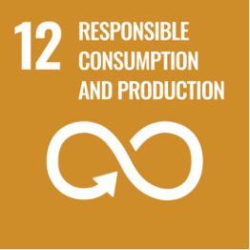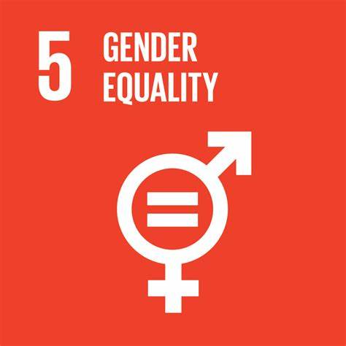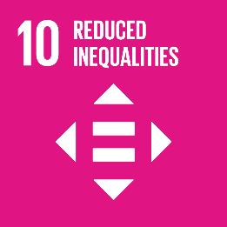

Review Mechanism
The Labor and Human Rights Policy will be reviewed annually by the Human Resources Manager to ensure compliance with evolving regulations, industry best practices, and international standards. A designated compliance officer will oversee implementation, monitor adherence, and address concerns. Regular audits, employee feedback mechanisms, and supplier assessments will be conducted to identify gaps and drive continuous improvements. Any necessary updates will be approved by senior management and communicated across all levels of the organization and supply chain.

Last Revision Date: 01.01.2025 Next Revision Date: 01.01.2026

Approved by: Signature of Approver:

Employee Acknowledgement
I acknowledge that I have received, read, and understood True Up Companies Labor and Human Rights Policy. I agree to comply with the principles outlined in the policy, including maintaining a safe, respectful, and inclusive work environment, upholding fair labor practices, and preventing discrimination, harassment, forced labor, and child labor.
I understand my responsibility to adhere to this policy in my daily work and interactions. I also acknowledge that I am required to report any violations or concerns through the appropriate reporting channels without fear of retaliation.
By signing below, I confirm my commitment to supporting True Up Companies’ efforts in fostering ethical and responsible business practices.

Name: ____________________
Designation: _______________
Signature: _________________
Date: _____________________

